  The World Bank in Vietnam |  | 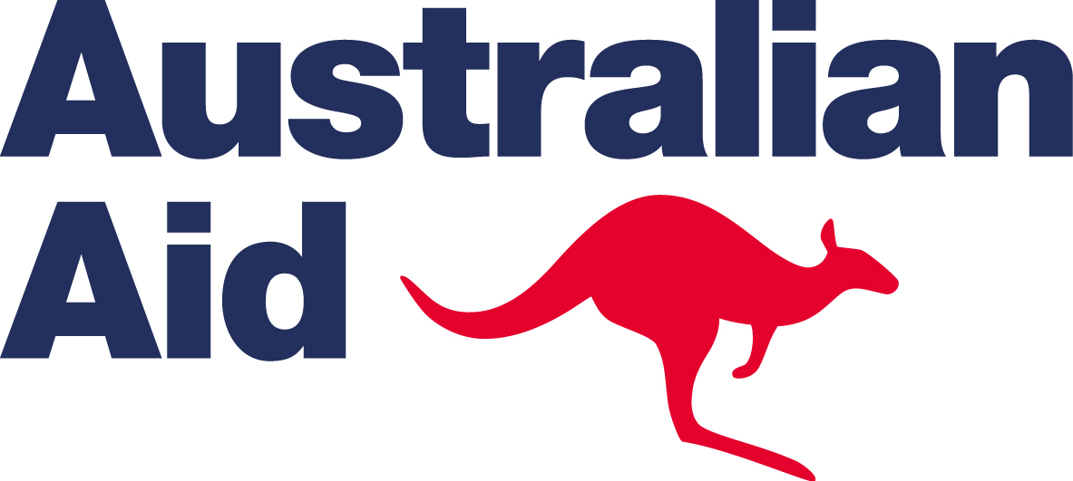  An Australian aid initiative
  Vietnam Development Information Center

EXPRESSION OF INTEREST

For the Vietnam Blended Learning Program Grant - Round 7

- Application steps

Step 1: Complete the ‘Expression of Interest’ (EoI) form in English.

Fill in information and complete 10 questions included in the Expression of Interests Template on pages 2 and 3 of this document. Applciations with insufficient information will not be accepted.
You are welcome to attach additional supporting documents such as organisational’s capacity building plan, samples of training courses to strengthen your EoI.

Step 2: Submit your completed Expression of Interest
Email your EoI to Ms. Dang Thi Ngoc Lan by email at ldang@worldbank.org
Clearly mark your email subject as: “VBLP Round 7 Application – <name of your organisation>”

Deadline of submission is 5.30 pm Friday 6th December 2013.
Short-listed Expressions of Interest will be invited to present their proposed ideas. Only the selected teams will develop full proposals. The best proposals will be awarded the Grant .
For further enquiries, please contact:
Ms. Đặng Thị Ngọc Lan
Tel: +84 4 39378703 Email : ldang@worldbank.org

- Information for proposal preparation

- Project objectives
Selected institutions are expected to use the grant funding to implement capacity building activities by
- Using innovative and blended learning methodologies to increase knowledge sharing and learning on the theme of Governance for specialists and practitioners nationally and internationally.
- Using blended learning design and facilitation methods, to ensure the learning experiences to be engaging, effective and inspiring for project’s participants and wider beneficiaries; and
- Integrating ICTs and action learning design and facilitation methods into project activities to respond to development needs which are in line with the Australia – Vietnam Joint Aid Program Strategy 2010–2015.

- The theme Governance and other reference information
The Vietnam Blended Learning Program aims to support Vietnamese local institutions in developing knowledge management activities and training programs which ultimately contribute to more efficient local and central governance, through the use of innovative learning technologies and blended approaches.
Expressions of Interests to the Vietnam Blended Learning Program Round 7 should focus on one of the following areas:
- Strengthening Accountability and Efficiency
- Expanding Access to Information
- Enhancing transparency
More information on governance, and the Governance work of the World Bank and Australian Aid, please visit the following website:
      - http://go.worldbank.org/C1YQMMPTW0
- http://go.worldbank.org/SGO4LFRSS0
- http://aid.dfat.gov.au/countries/eastasia/vietnam/Pages/effective-governance.aspx

- Project implementation timeline: 6 - 8 months, since the contract is signed, starting from Feb. to Aug. 2014

- Notes on project budget
Selected institutions will receive a grant of approximately USD30,000 to finance project activities according to the approved budget. It is also expected that the granted organizations will make in-kind contribution through staff work hours and facilities during the implementation of the projects.

Eligible expenditures:
- Consultancy work in designing instructional and materials, reviewing training materials, facilitating learning events and translating training materials from/to Vietnamese. The Vietnam Blended Learning Program aims to help organizations in improving existing methods and materials by applying new ICT tools, rather than funding for developing new training contents.
- Fee for project evaluation’s activities, i.e collecting evaluation data and writing final report.
- Costs borne from organizing training events, e.g. venue, facilities, printing of training materials.
- Minimum travel costs – as ICTs such as the web, phone and video-conferencing drastically reduce the need for travel.
- Low - cost ICT equipment could be considered if found justified.
Ineligible expenditures:
- Operating expenses, such as electricity, vehicles, and equipment.
- Staff salaries for implementing and monitoring project activities.
- Expression of Interest Template

1. Vietnam organization responsible for project implementation
Name of organization
Address
Website
Contact person
Job Title
Telephone
Email address

2. Partner organization/s: institutions which would provide technical expertise and training contents to the project.
Name of organization
Address
Website
Contact person
Telephone number
Email address
Is this a new partnership? | Yes  No
- State your organization’s core business

- Describe your capacity in delivering
- Knowledge management activities on topics relating governance

- Training programs applying innovative and information and communication technologies

- What are the challenges in delivering knowledge management activities and training programs that you have been facing?

- Describe your proposed project

    - Project title:
    - Overall goal and specific objectives
    - Proposed key activities and time-frame
    - Expected outputs and impacts (including list the results of the project, number of beneficiaries, and expected changes on behavior and performance of beneficiaries as the results of the project)
    - Proposed methods to evaluate impacts of the project
- The innovations in your delivery approach

- How will winning the Vietnam Blended Learning Grant help overcome the identified challenges and improve your organization’s capacity in implementing knowledge management and training programs?

- How will your project’s impacts contribute to the achievement of the Australia – Vietnam Joint Aid Program Strategy 2010–2015?

- What are your plans to sustain the project’s results after 6 months and 12 months?

- Please give 3 rationales why the Vietnam Blended Learning Program should reward your project.

Annex - Australia – Vietnam Joint Aid Program Strategy 2010–2015

Proposed focus areas and expected outcomes
Our aid program focuses on the areas where Australia can make a difference in responding to Vietnam’s development challenges outlined above. Our focus reflects the priority areas that the Government of Vietnam has identified in its Social and Economic Development Strategy 2011–2020. These are the areas where progress is needed for Vietnam to reach its goal of becoming an industrialised country by 2020. Our program’s core areas are
- Human resource development
- Economic integration (including infrastructure)
- Environmental sustainability (including climate change and water and sanitation).
These core areas also reflect the five core goals of the Australian aid program
- Saving lives—by increasing access to safe water and sanitation
- Promoting opportunities for all—by providing enhanced leadership, knowledge and technical skills to Vietnamese through development scholarships
- Sustainable economic development—by investing in infrastructure and the opening of markets as well as reducing the negative impacts of climate change
- Effective governance—by helping the Vietnamese Government modernise its institutions so they can support the next stage of the country’s development (institutional strengthening is a crosscutting issue for all of Australia’s sector programs)
- Humanitarian and disaster response—by supporting Vietnam’s efforts to reduce the impacts of natural disasters.
Our bilateral investments are complemented by Australian investments in dealing with trans-boundary issues such as infectious diseases, avoidable blindness, HIV/AIDS, people trafficking and regional trade integration. Australian Volunteers will continue to make a valuable contribution to building the capacity of individuals, organisations and communities through skills and knowledge exchange.

The complete document of the “Australia – Vietnam Joint Aid Program Strategy 2010–2015” is available at http://aid.dfat.gov.au/Publications/Pages/81_1838_8042_1384_6380.aspx

